Luke Pepin

GEOG – African Cultures Assignment

Group 1 – Amhara – Physical Environment

Located in central and northern Ethiopia the Amhara region is one of the country’s largest geographical areas. The region's physical environment is characterized by its high elevation and wide variety of ecosystems.

The image on the left showcases the high elevation of the region, ranging from 500 to 4,500 meters (4,900 to 14,800 ft.) above sea level. The region does not only include high elevations but also high changes in elevation. As a result, common features of the terrain include steep mountains, deep valleys, and winding rivers. All of which work together to present challenges and opportunities for transportation, infrastructure and human settlement. This high elevation not only influences the region's climate but also shapes its unique biodiversity, with diverse ecosystems thriving in cooler conditions.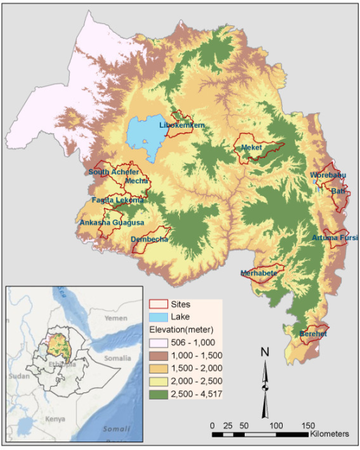

The region's diversity is attributed to its mountain ranges, including the Simien Mountains, consisting of many jagged peaks and rugged cliffs. The region's highlands and lowlands are connected through its vast river and stream systems as they carve deep gorges through the mountain ranges. Descending from the mountains and down the rivers are the plateaus and valleys of the region, which holds immense agricultural importance, serving as essential contributors to the economy and food security.

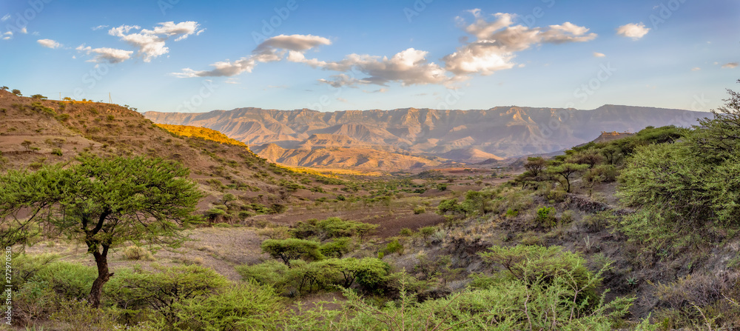

Amhara is a beautifully diverse region of Ethiopia; its high elevation results in a unique blend of landscapes results in a remarkable array of natural wonders and scenic vistas. The region challenges ideas of an environmentally indistinguishable country and nation, to one that varies greatly in its environments.

References:

1. World Health Organization. (2012). The global burden of disease: 2004 update. Retrieved from https://openi.nlm.nih.gov/detailedresult?img=PMC3493314_1475-2875-11-165-1&query=&favor=o,d,e,g,oc,pr,pg,t&it=c,m,mc,p,ph,u,x,xg,xm&sub=b,c,e&at=ab,bk,bf,cr,dp,di,ed,hs,ib,in,lt,mr,ma,ne,ob,or,os,pr,rr,re,ra,rw,sr,ot&vid=1&req=4&simResults=PMC4274722_s12900-014-0022-0-2

2. Adobe Stock. (n.d.). Beautiful mountain landscape with traditional Ethiopian houses, Amhara region near city Lalibela, Ethiopia, Africa. Retrieved from https://stock.adobe.com/images/beautiful-mountain-landscape-with-traditional-ethiopian-houses-amhara-region-near-city-lalibela-ethiopia-africa/272970530

3. Benin, S., Ehui, S., & Pender, J. (2003). Policies for sustainable land management in the Highlands of Ethiopia. Retrieved from https://www.ncbi.nlm.nih.gov/pmc/articles/PMC10248089/#:~:text=Land%20and%20water%20resource%20degradation,deforestation%2C%20and%20loss%20of%20biodiversity.